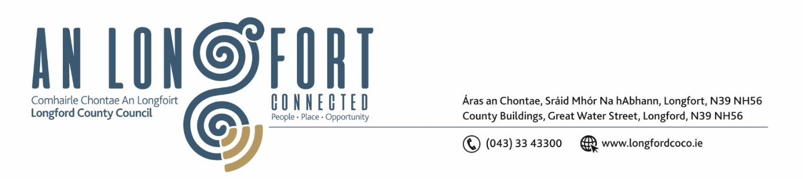

***LONGFORD MUNICIPAL DISTRICT***

***Please note meeting will be held in Council Chamber and via Microsoft Teams***

**14th October 2021.**

**To: Each Member of Longford Municipal District.**

**Dear Member,**

You are requested to attend the Meeting of Longford Municipal District to be held

**in Council Chamber, Aras an Chontae and via Microsoft Teams** on **Wednesday 27th October 2021 at 3.30pm** to transact business, as set out on the Agenda hereunder.

**Yours sincerely**,

Ann Marie Mc Keon

_______________

**Ann Marie Mc Keon**

**Meetings Administrator.**

**AGENDA**

Prayer before meeting.

**1.** Confirmation of Minutes of Longford Municipal District Meeting held on Wednesday 22nd September 2021 – copy enclosed.

**2.** Matters arising from Minutes.

**3.** Declaration of Interest by Members.

**4.** Management Report – to follow.

**5**. Proposed Projects/Expression of interests - enclosed.

**6.** Consideration of2022 General Municipal Allocation.

**7.** Consideration of the 2022-2024 Multi-Annual Restoration Improvement Programme – to follow.

**8.** Consideration of Free Parking Arrangements during the Christmas period.

**9.** Consideration of applications for funding under the 2021 Community Grant Support

Scheme – to follow.

**10. Notices of Motions, submitted by Councillors, as listed hereunder –**

**Councillor Martin Monaghan**

1. That a pedestrian crossing be provided at the entrance to the Albert Reynolds Peace Park (The Mall).
2. That the stretch of footpath at the head of L 1007 Lamagh, Newtownforbes be replaced with concrete rather than the slabbing that is there at present.